Cato Syversen
Chief Executive
Creditsafe Group
Bryn House
Caerphilly Business Park
Van Road
Caerphilly
CF83 3GG

24 October 2014

Dear Mr Syversen

Changes to credit ratings – impact on printing companies

I am writing on behalf of the British Printing Industries Federation (BPIF), the leading trade association and business support organisation representing companies in the printing, packaging and graphics communications industry, to voice our concerns regarding the impact on UK printing companies of the recent upgrade to your credit ratings model.

As we understand it, this upgrade involves a data set of more than 88m trade payments, sourced directly from suppliers’ accounting software and fed automatically into Creditsafe’s ratings algorithm. This has resulted in many companies across the printing industry suffering significant downgrades, with some going from ‘very low risk’ (with scores in the high 80s and 90s out of 100) to ‘very high risk’. Indeed the scale of this has been so pervasive that many of our members have made the assumption – rightly or wrongly – that Creditsafe has downgraded their overall assessment of the printing sector as a whole.

It would be helpful if you could explain why this widespread shift in companies’ assessments has occurred, and if you could provide us with some background on how your new model operates in practice and why you consider this tool to be more accurate than its predecessor. We would be pleased to pass this information on to our member companies, in order they in turn can better understand the changes you have made and the rationale behind them. In particular, some companies believe that part of the reason for the widespread reduction in recommended credit limits lies in their payment performance data and specifically the number and frequency of any late payments. If this is the case then we would wish to ascertain whether your model factors in payment cycles agreed with customers, since the application of a blanket 30-day payment cycle would mean any company paying to agreed terms of, say, 60 days would still be deemed ‘late’ by the system.

It would also be helpful if you could comment on whether it might be possible to improve the transparency of the credit reports, so that the cause of a drop in rating might be made clear to the companies affected. I am sure you will agree that where this data is invisible and anonymous – or difficult to access – users then have to trust that the providers of the payment performance data are feeding accurate and pertinent information into the system. To rely on blind faith in this way would in our view be a recipe for user dissatisfaction and likely to cause ongoing unease and uncertainty among our member firms.
I look forward to hearing from you.

Yours sincerely

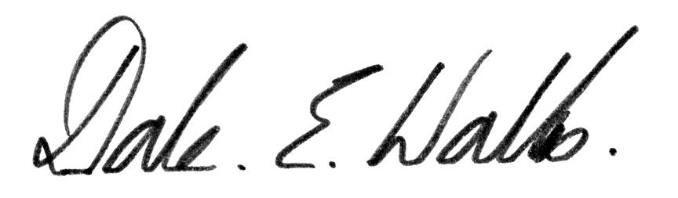

Dale Wallis
Membership Director

Email: dale.wallis@bpif.org.uk
Tel: 07736 828450

